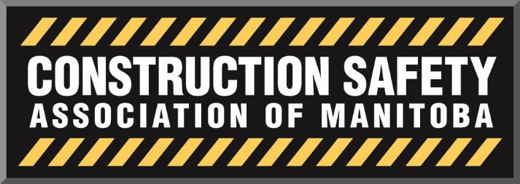

Mechanical, Electrical, Manufacturers and Suppliers Divisional Safety Meeting
November 4th, 2015
12:00pm Tribune Room – 1447 Waverley Street

In Attendance:
Dale Kowalke | Quality Air Control
Doug Matilla | More-Lite Electric Ltd
Greg Edwards | Razar Contracting
Kayla Lefreniere | Rolly's Mechanical
Ken Nimchuk | Construction Safety Association of MB
Meagan Doherty | Construction Safety Association of MB
Mike Jones | Construction Safety Association of MB
Peter Cooke | Ambassador Mechanical Corp
Ray Phillips | Sperling Industries
Robb Fletcher | ABCO
Vance De Santis | Pembina Co-op

Call to Order & Introductions
Meeting called to order at 12:06pm. and began with an introduction of committee members in attendance.

It was mentioned that the divisional meetings goal is to have a reasonable sized group with like-minded people and is why the current meeting is involving all three divisions.

Acceptance of Previous Minutes
Minutes accepted

Acceptance/Additions to Agenda
No additions to agenda

Discussion Items

CSAM Strategic Planning:

Mike began by summarizing the strategic planning process which involved key stakeholders. He further explained CSAM’s five high-level priority areas:

- Continue to build a culture of safety – shift the safety culture within organizations about safety
- Leverage role as industry, independent from government – ensure message is clear that CSAM is not government
- Leverage data and online platforms to target outreach – Determine who we are currently servicing, and who we are not servicing so we can strive to work towards additional services for whom we are already servicing and reaching out to companies whom we are not currently servicing to introduce how CSAM can help them.
- Lead and innovate in service delivery beyond COR – COR is not all we do, CSAM is your prepaid safety consultants. Our goal is to look at what we can do for non COR certified companies as well as how we can further help COR certified companies.
- Continue to build organizational strength and alignment – have a strong divisional and advisory board, along with retaining staff through similar competition.

CSAM’s mid-level Year 1 Strategic action plan includes the following five areas:
- Governance
  - CSAM’s goal is to build and maintain strong divisional and advisory committees.
  - A chair from each division will be elected to sit on the Advisory board. This will ultimately help flow information from the job site up to the advisory board where management sits.
  - Ensure that CSAM has a good annual report of CSAM’s committees and operations.

- Operations
  - Goal is to rebrand CSAM as many think we are just COR
  - CSAM wants to go back to its original focus of being a prepaid safety consultant by helping people create and follow a health and safety plan.
  - CSAM does not have the capacity to do an annual audit on all companies. A lot of COR certified companies also do not need an audit every year.
  - If the annual audit is taken out, CSAM will provide more consulting services and focusing on quality assurance by visiting job sites to ensure that companies are acting safely in their day to day operations rather than just at audit time.
  - CSAM on Tour’s focus is on the small contractors that COR is not necessary for but still need to develop a safety plan.
  - A new vision for CSAM is to provide an online and paperwork training for small companies to teach them the basic safety information needed for working on a COR jobsite. This will teach small companies what they want and really need to know.

- Client Services
  - CSAM would also like to become more of a service provider to get small companies interested in health and safety which will make it easier for primes to get small non-cor companies on site.
  - Another focus is to get more youth engagement in safety. This will help shift the safety culture at a young age.
  - CSAM is looking a ways to target younger workers and provide the needed training so they arrive into the workforce being well educated in safety.
- COR/SECOR
  - In current developments of an E-audit submission system
  - In 2016, CSAM will accept electronic audits but will still require supporting documentation although we will look over the documents submitted and determine if we truly need the information annually.

- Quality Assurance
  - Ensure consistency in our operations
  - CALVIN, our new database allows us to do a lot more. Once staff get full training we can utilize the database and do things that we never have been able to do before.
  - The end goal is to get the E-audit to link to CALVIN to be entered and stored.

Group Comments
Below are the main comments the committee mentioned regarding CSAM’s strategic plan summary and mid-level audit plan:
- Recommendation to get Apprenticeship and College representative to sit in on meetings
- Safety training in Apprenticeship program and Red River trades programs.
- Notifying safety managers when CSAM is going on sites or informing subs when you have gone on their site

CSAM Advisory Representative
An email will be sent out asking all group members whether they are interested in being elected to be the chair of the divisional committee. After we determine the candidates that have volunteered, we will be sending out a second e-mail that will ask all members to vote for who they would like to be the chair.

The chair will be announced before the next meeting.

Next Meeting:
TBD – Potential date of January 12th 2016

Adjournment:

The meeting was adjourned at 1:46pm

